- \Operation\Good tube discharge\Tube flipper
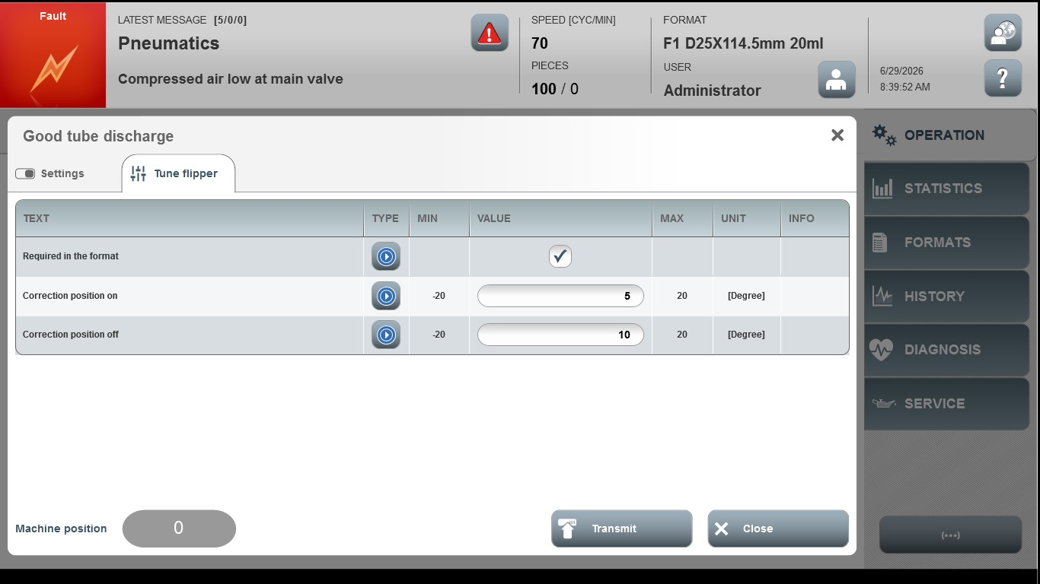
Acceptance criterion | Limits | Pass / Fail: Dev-No. | Date | Initials
Screen matches screenshot | N / A
Correction, position on | -20 … 20
Correction, position off | -20 … 20

